# Task 2

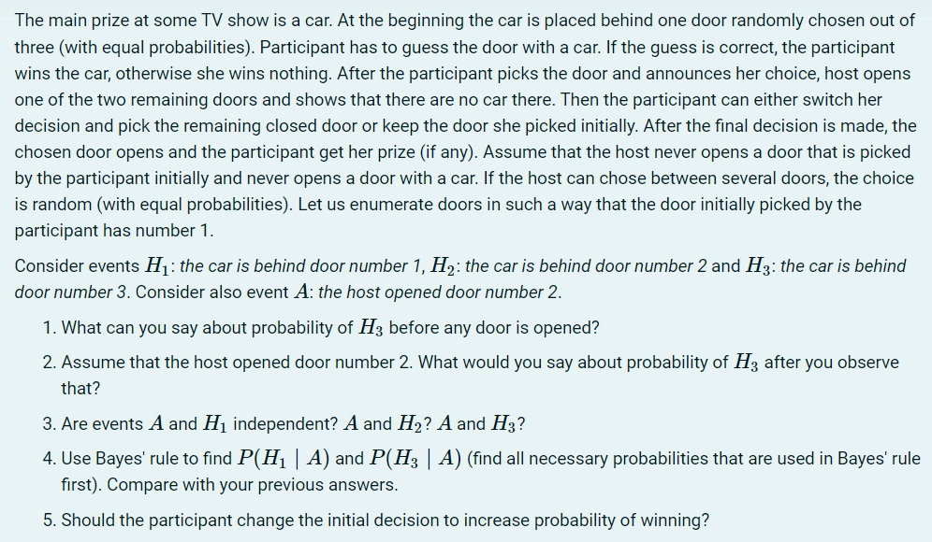

1.First let’s find probabilities of events $H_{1},H_{2},H_{3}$.

Before the games starts the car is placed behind one of them with equal probabilities, so we can say that $P\left(H_{1}\right)=P\left(H_{2}\right)=P\left(H_{3}\right)=1/3$.

Probability of host opening any of the 3 doors is also equal 1/3 by default, so .

2. Let us consider a situation in which host opened door number 2, and let’s see what could lead to that.

We know that at the start participant of the show picked door 1. Initially, $P(H_{1})$ is 1/3, so $P\left(H_{2} or H_{3}\right)=1-P\left(H_{1}\right)=2/3$. It means, that car is twice as likely to be behind door 2 or 3 as being behind door 1. After host opens door 2 this assumption doesn’t change, car is still twice likely to be behind doors 2 or 3, but as we now know, it isn’t behind door 2. This means, that probability of 2/3 is now being distributed not between doors 2 and 3, but it belongs exclusively to door 3